What is an Iterated Block Cipher?
An Iterated Block Cipher is a type of encryption method where:
- Plaintext and ciphertext are divided into fixed-size blocks (for example, 128 bits).
- The encryption is done by repeating a function called Round Function (F) many times.
- This repetition is called rounds.

What is Round Function (F)?
- It is called a round function not because of its shape,
- But because it is applied repeatedly in multiple rounds.
- Each round makes the data more secure.

What is Feistel Cipher?
- Feistel Cipher is a structure used to build block ciphers.
- It is not a specific algorithm, but a design method.
- Example: DES uses Feistel structure.
Feistel Cipher (Encryption + Decryption)
Encryption
Take plaintext block and divide into two halves:
P=(L₀​,R₀​)
- L₀ = Left half
- R₀ = Right half
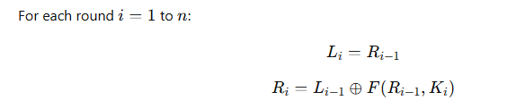
Where:
- F = Round function
- Kᵢ = Subkey for that round
- ⊕ = XOR operation
After last round: C=(L_{n}​,R_{n}​)
That is the ciphertext.
Decryption:
Rounds go backward with ciphertext: C=(L_{n}​,R_{n}​)
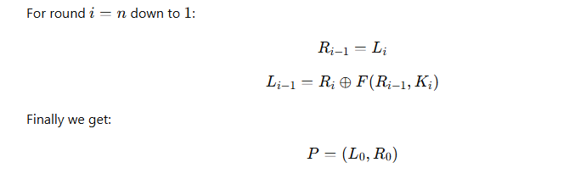
• Decryption works for any function F

• But security depends on choosing a strong F
DES Numerology মানে কী?
এখানে DES এর গুরুত্বপূর্ণ সংখ্যাগুলো বলা হয়েছে।

📌 DES এর প্রধান বৈশিষ্ট্য

১️. Feistel Cipher
Data Encryption Standard (DES) একটি Feistel structure ব্যবহার করে।

২️. ৬৪ বিট ব্লক
- DES একবারে ৬৪ বিট ডেটা encrypt করে।

৩️. ৫৬ বিট key
- আসল security key হলো ৫৬ বিট।
- যদিও key দেখতে ৬৪ বিট, কিন্তু ৮ বিট parity হিসেবে ব্যবহৃত হয়।

৪️. ১৬ টি round
- DES মোট ১৬ বার round চালায়।
- প্রতিবার ডেটা আরও বেশি মিক্স হয়।

৫️. প্রতি round এ ৪৮ বিট subkey
- ৫৬ বিট মূল key থেকে প্রতি round এ ৪৮ বিট subkey তৈরি হয়।
- সেটাই round function এ ব্যবহার হয়।

🔐 Security কার উপর নির্ভর করে?
👉 সবচেয়ে গুরুত্বপূর্ণ অংশ হলো S-box।
- প্রতিটি S-box:
  - ৬ বিট input নেয়
  - ৪ বিট output দেয়
এই S-box গুলোই আসল security তৈরি করে।

One Round of DES Block Diagram:
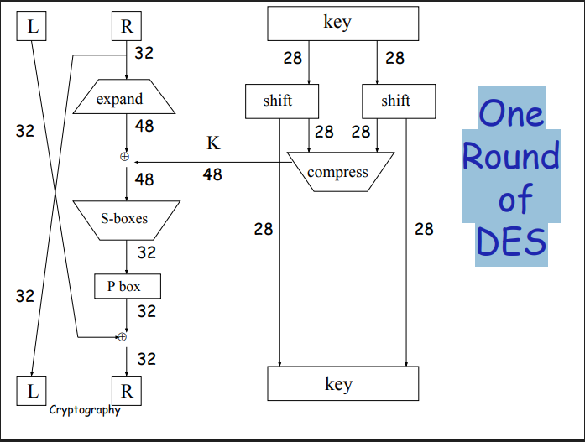
Question and Answer:
Describe the structure and operation of the DES algorithm, including its key size and block size.

Structure of DES
- DES is a Feistel cipher.
- Feistel structure means:
  - Plaintext block is split into left (L) and right (R) halves.
  - The right half goes through a round function (F), then combined with the left half using XOR.
  - Halves are swapped each round.
  - This is repeated for 16 rounds.
- There is an initial permutation (IP) at the start and a final permutation (IP⁻¹) at the end.

Key Size and Block Size
- Block size: 64 bits (plaintext divided into 64-bit blocks)
- Key size: 56 bits (even though represented as 64 bits, 8 bits are parity)
- Rounds: 16 rounds
- Subkey per round: 48 bits generated from 56-bit key using key schedule.

What role do S-boxes play in block ciphers like DES?
Answer:
In DES, an S-box (Substitution box) is a small lookup table used in the round function.
Role of S-Boxes
- Introduce Non-Linearity (Confusion)
  - Without S-boxes, DES would be mostly linear (XOR, permutation), which is easy to break.
  - S-boxes make the relationship between key and ciphertext complex.
- Mix Input Bits
  - 6-bit input → 4-bit output
  - Bits from input are scrambled in a non-linear way.
- Prevent Cryptanalysis
  - S-boxes are designed to resist linear and differential attacks.
  - They are the main source of security in DES.
- Compact Transformation
  - Reduces 6-bit input to 4-bit output while adding complexity.
  - Helps the 48-bit expanded R half be compressed back to 32 bits after the round function.
Why DES Encrypt-Decrypt-Encrypt with 2 keys?
Answer:
DES uses Encrypt-Decrypt-Encrypt with 2 keys to increase security (from 56-bit to 112-bit), maintain backward compatibility with single-key DES, and prevent attacks that simple double encryption (E-E) would be vulnerable to.
Bangla:
DES 2টি key ব্যবহার করে Encrypt-Decrypt-Encrypt করে যাতে নিরাপত্তা বৃদ্ধি পায় (56-bit থেকে 112-bit), একক key DES এর সাথে backward compatibility বজায় থাকে, এবং সাধারণ double encryption (E-E) দ্বারা হওয়া আক্রমণ থেকে প্রতিরোধ করা যায়।
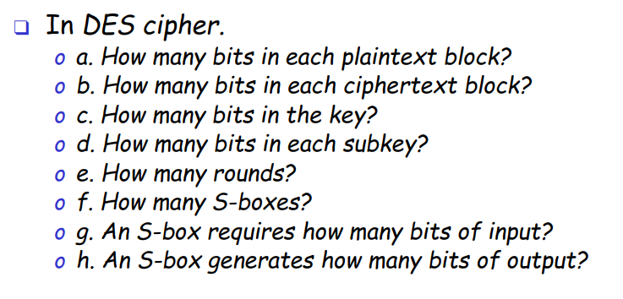a. How many bits in each plaintext block?
- Answer: 64 bits
- Explanation: DES encrypts data 64-bit blocks at a time.

b. How many bits in each ciphertext block?
- Answer: 64 bits
- Explanation: DES preserves block size; ciphertext block = 64 bits.

c. How many bits in the key?
- Answer: 56 bits
- Explanation: Original key is represented as 64 bits, কিন্তু 8 bits parity হিসেবে থাকে। Security key = 56 bits.

d. How many bits in each subkey?
- Answer: 48 bits
- Explanation: প্রতিটি round এর জন্য subkey 48 bits তৈরি হয় মূল 56-bit key থেকে।

e. How many rounds?
- Answer: 16 rounds
- Explanation: DES uses 16 Feistel rounds.

f. How many S-boxes?
- Answer: 8 S-boxes per round
- Explanation: 48-bit input → 8 groups of 6-bit → 8 S-boxes process them.

g. An S-box requires how many bits of input?
- Answer: 6 bits
- Explanation: Each S-box takes 6-bit input to produce output.

h. An S-box generates how many bits of output?
- Answer: 4 bits
- Explanation: Each S-box produces 4-bit output, which are combined to form 32-bit output after S-box stage.

